Cairo University

Faculty of Computers and Information

**CS352 – Software Engineering II**

**Software design specification document**

**2019**

**Project Team**

|  |  |  |  |
| --- | --- | --- | --- |
| **ID** | **Name** | **Email** | **Mobile** |
| 20160088 | Joseph medhat melad | [Josephmedhat111@gmail.com](mailto:Josephmedhat111@gmail.com) | 01283957494 |
| 20160063 | Omama Mostafa Helmy | omamamostafa8@gmail.com | 01111395497 |
| 20160068 | Engy Ayman rofaeel | engyayman175@gmail.com | 01278270385 |

**Eng Nehal**

Contents

Class diagram design 2

Entity Relationship diagram 3

Github repository link 3

# 

# Class diagram design

getUserQuizScore():integer

UserScore

Quiz_id

User_id

UserQuiz

User_id

UserAnswer

getAnswerScore():integer

UserQuiz_id

Answer_id

# Entity Relationship diagram

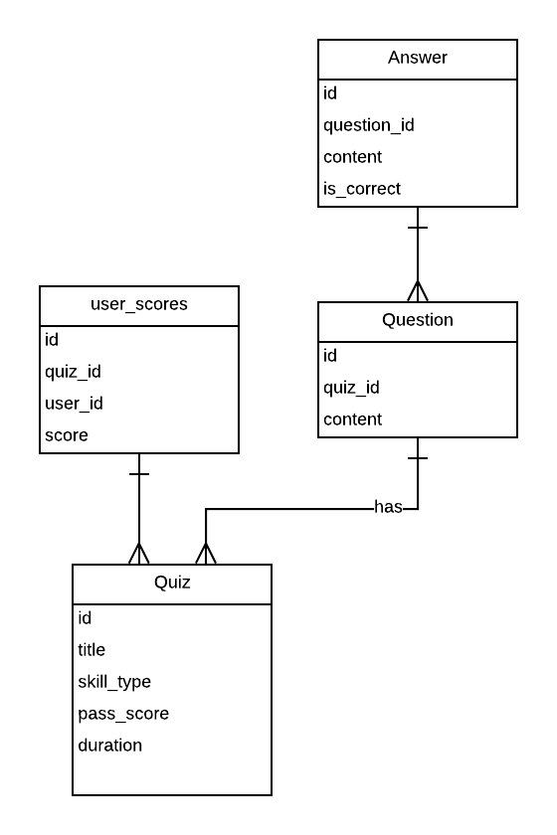

# Classes Documentation

|  |  |  |
| --- | --- | --- |
| Class Name | Attributes | Description |
| Answer | Question_id.  Contents.  Is_correct. | Contain all answers related to questions. |
| Question | Quiz_id.  Contents. | Contain all questions related to quizzes. |
| Quiz | Title.  Skill_type.  Pass_score.  Duration. | Contain all required quizzes. |
| UserAnswer | User_id.  Answer_id.  userQuiz_id. | Contain the user answers. |
| UserQuiz | User_id.  Quiz_id  User_score | Contain user quiz with the score that user got. |

# Github repository link

<https://github.com/josephmedhat/SW-project-APIs.git>

# Slack channel link

<https://w1552332631-5xb655998.slack.com/messages>

# Trello board link

<https://trello.com/b/FMVJH1a6/joseph-medhat-team>

# Attending kickoff meeting

Joseph medhat